Downloading...
From: https://drive.google.com/uc?id=1VJaDVtDUtKQMmhRAqr3t-fgng899ZdRV
To: /content/Python Application Usage Log Data Set.xlsx
100%|██████████| 1.68M/1.68M [00:00<00:00, 139MB/s]
Epoch 1/300
19/19 ━━━━━━━━━━━━━━━━━━━━ 4s 49ms/step - loss: 0.3835 - val_loss: 0.4096 - learning_rate: 0.0010
Epoch 2/300
19/19 ━━━━━━━━━━━━━━━━━━━━ 1s 28ms/step - loss: 0.3687 - val_loss: 0.3240 - learning_rate: 0.0010
Epoch 3/300
19/19 ━━━━━━━━━━━━━━━━━━━━ 1s 25ms/step - loss: 0.2772 - val_loss: 0.3199 - learning_rate: 0.0010
Epoch 4/300
19/19 ━━━━━━━━━━━━━━━━━━━━ 1s 29ms/step - loss: 0.3012 - val_loss: 0.3351 - learning_rate: 0.0010
Epoch 5/300
19/19 ━━━━━━━━━━━━━━━━━━━━ 1s 25ms/step - loss: 0.2744 - val_loss: 0.3666 - learning_rate: 0.0010
Epoch 6/300
19/19 ━━━━━━━━━━━━━━━━━━━━ 1s 26ms/step - loss: 0.2597 - val_loss: 0.3556 - learning_rate: 0.0010
Epoch 7/300
19/19 ━━━━━━━━━━━━━━━━━━━━ 1s 25ms/step - loss: 0.2528 - val_loss: 0.3848 - learning_rate: 0.0010
Epoch 8/300
19/19 ━━━━━━━━━━━━━━━━━━━━ 1s 27ms/step - loss: 0.2467 - val_loss: 0.4155 - learning_rate: 0.0010
Epoch 9/300
19/19 ━━━━━━━━━━━━━━━━━━━━ 0s 21ms/step - loss: 0.2169
Epoch 9: ReduceLROnPlateau reducing learning rate to 0.0005000000237487257.
19/19 ━━━━━━━━━━━━━━━━━━━━ 1s 26ms/step - loss: 0.2178 - val_loss: 0.4228 - learning_rate: 0.0010
Epoch 10/300
19/19 ━━━━━━━━━━━━━━━━━━━━ 1s 34ms/step - loss: 0.2387 - val_loss: 0.4180 - learning_rate: 5.0000e-04
Epoch 11/300
19/19 ━━━━━━━━━━━━━━━━━━━━ 1s 45ms/step - loss: 0.2064 - val_loss: 0.3867 - learning_rate: 5.0000e-04
Epoch 12/300
19/19 ━━━━━━━━━━━━━━━━━━━━ 1s 43ms/step - loss: 0.2452 - val_loss: 0.4237 - learning_rate: 5.0000e-04
Epoch 13/300
19/19 ━━━━━━━━━━━━━━━━━━━━ 1s 37ms/step - loss: 0.2147 - val_loss: 0.4240 - learning_rate: 5.0000e-04
Epoch 14/300
19/19 ━━━━━━━━━━━━━━━━━━━━ 1s 52ms/step - loss: 0.2045 - val_loss: 0.4126 - learning_rate: 5.0000e-04
Epoch 15/300
17/19 ━━━━━━━━━━━━━━━━━━━━ 0s 31ms/step - loss: 0.2006
Epoch 15: ReduceLROnPlateau reducing learning rate to 0.0002500000118743628.
19/19 ━━━━━━━━━━━━━━━━━━━━ 1s 33ms/step - loss: 0.2026 - val_loss: 0.4076 - learning_rate: 5.0000e-04
Epoch 16/300
19/19 ━━━━━━━━━━━━━━━━━━━━ 1s 26ms/step - loss: 0.2094 - val_loss: 0.3994 - learning_rate: 2.5000e-04
Epoch 17/300
19/19 ━━━━━━━━━━━━━━━━━━━━ 1s 25ms/step - loss: 0.2062 - val_loss: 0.4089 - learning_rate: 2.5000e-04
Epoch 18/300
19/19 ━━━━━━━━━━━━━━━━━━━━ 0s 25ms/step - loss: 0.1999 - val_loss: 0.4176 - learning_rate: 2.5000e-04

VAL — MAE: 420.08 | RMSE: 623.47 | MAPE: 33.33%

VAL (accuracy-optimized) — thr: 499.056 | Acc: 96.15% | F1: 0.98 | P: 0.96 | R: 1.00
Confusion matrix [TN FP; FN TP]:
[[ 0 1]
[ 0 25]]

VAL (optimal-F1) — thr: 499.056 | Acc: 96.15% | F1: 0.98
Epoch 1/20
20/20 ━━━━━━━━━━━━━━━━━━━━ 4s 20ms/step - loss: 0.3959
Epoch 2/20
20/20 ━━━━━━━━━━━━━━━━━━━━ 0s 21ms/step - loss: 0.2975
Epoch 3/20
20/20 ━━━━━━━━━━━━━━━━━━━━ 0s 19ms/step - loss: 0.2975
Epoch 4/20
20/20 ━━━━━━━━━━━━━━━━━━━━ 0s 21ms/step - loss: 0.2795
Epoch 5/20
20/20 ━━━━━━━━━━━━━━━━━━━━ 1s 27ms/step - loss: 0.2681
Epoch 6/20
20/20 ━━━━━━━━━━━━━━━━━━━━ 1s 33ms/step - loss: 0.2641
Epoch 7/20
20/20 ━━━━━━━━━━━━━━━━━━━━ 1s 31ms/step - loss: 0.2601
Epoch 8/20
20/20 ━━━━━━━━━━━━━━━━━━━━ 1s 32ms/step - loss: 0.2614
Epoch 9/20
20/20 ━━━━━━━━━━━━━━━━━━━━ 1s 25ms/step - loss: 0.2406
Epoch 10/20
20/20 ━━━━━━━━━━━━━━━━━━━━ 0s 20ms/step - loss: 0.2262
Epoch 11/20
20/20 ━━━━━━━━━━━━━━━━━━━━ 1s 20ms/step - loss: 0.2403
Epoch 12/20
20/20 ━━━━━━━━━━━━━━━━━━━━ 0s 20ms/step - loss: 0.2224
Epoch 13/20
20/20 ━━━━━━━━━━━━━━━━━━━━ 0s 19ms/step - loss: 0.2193
Epoch 14/20
20/20 ━━━━━━━━━━━━━━━━━━━━ 0s 20ms/step - loss: 0.2113
Epoch 15/20
20/20 ━━━━━━━━━━━━━━━━━━━━ 0s 19ms/step - loss: 0.1940
Epoch 16/20
20/20 ━━━━━━━━━━━━━━━━━━━━ 0s 19ms/step - loss: 0.2003
Epoch 17/20
20/20 ━━━━━━━━━━━━━━━━━━━━ 0s 20ms/step - loss: 0.1882
Epoch 18/20
20/20 ━━━━━━━━━━━━━━━━━━━━ 0s 20ms/step - loss: 0.2163
Epoch 19/20
20/20 ━━━━━━━━━━━━━━━━━━━━ 0s 20ms/step - loss: 0.1888
Epoch 20/20
20/20 ━━━━━━━━━━━━━━━━━━━━ 1s 19ms/step - loss: 0.2076
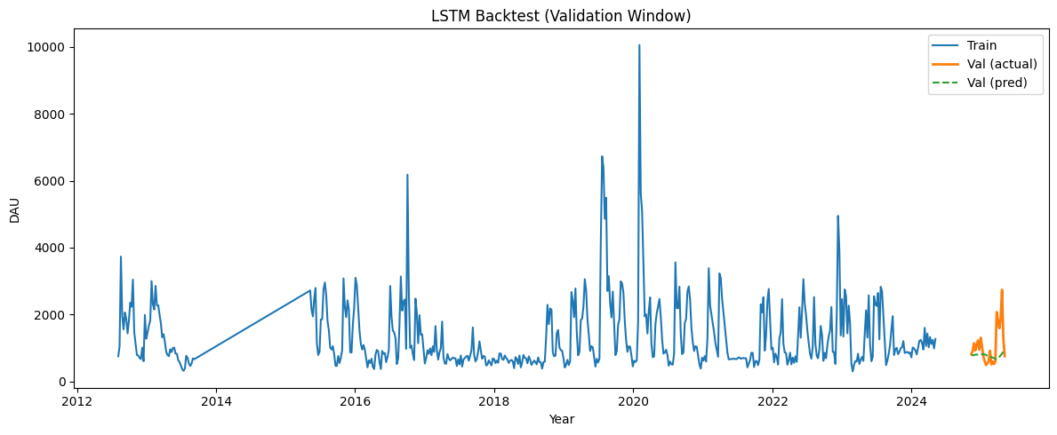
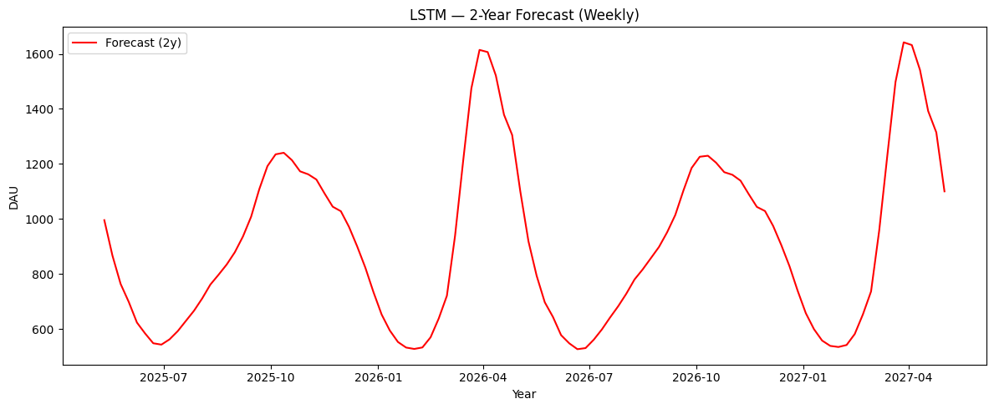

▶ Validation (fixed TRAIN-median threshold)
Threshold: 1003.513
Accuracy : 57.69%
F1 Score : 0.00
Precision: 0.00
Recall : 0.00
Confusion matrix [TN FP; FN TP]:
[[15 0]
[11 0]]

▶ Validation (accuracy-optimized threshold)
Threshold: 499.056
Accuracy : 96.15%
F1 Score : 0.98
Precision: 0.96
Recall : 1.00
Confusion matrix [TN FP; FN TP]:
[[ 0 1]
[ 0 25]]

